**INTERNATIONAL UNIVERSITY**

VIETNAM NATIONAL UNIVERSITY HCMC

**School of Computer Science & Engineer**

**Report Lab 4**

Course: WEB APPLICATION DEVELOPMENT

Lab Instructor: Assoc. Prof.Nguyen Van Sinh

Lab Instructor: Vo Duc Khoi, MSc

Group: ITIT22IU01

Name: Chau Thanh Phat

ID: ITITIU21135

**Lab 4: Web Session using Cookie**

**Exercise 1:**

SimpleCookies.java – Servlet class conquers the whole process.

My code:

/*

* Click nbfs://nbhost/SystemFileSystem/Templates/Licenses/license-default.txt to change this license

* Click nbfs://nbhost/SystemFileSystem/Templates/JSP_Servlet/Servlet.java to edit this template

*/

import jakarta.servlet.ServletException;

import jakarta.servlet.annotation.WebServlet;

import jakarta.servlet.http.Cookie;

import jakarta.servlet.http.HttpServlet;

import jakarta.servlet.http.HttpServletRequest;

import jakarta.servlet.http.HttpServletResponse;

import java.io.IOException;

import java.io.PrintWriter;

/**

*

* @author thanhphatchau

*/

@WebServlet(urlPatterns = {"/SimpleCookies"})

public class SimpleCookies extends HttpServlet {

/**

* Processes requests for both HTTP <code>GET</code> and <code>POST</code>

* methods.

*

* @param request servlet request

* @param response servlet response

* @throws ServletException if a servlet-specific error occurs

* @throws IOException if an I/O error occurs

*/

protected void processRequest(HttpServletRequest request, HttpServletResponse response)

throws ServletException, IOException {

response.setContentType("text/html;charset=UTF-8");

PrintWriter out = response.getWriter();

Cookie cookie = new Cookie("thanhphatchau","ititiu21135");

response.addCookie(cookie);

cookie.setPath("/SimpleCookies");

cookie.setDomain("http://localhost:8080/lab4/SimpleCookies?");

cookie.setMaxAge(3600);

try {

/* TODO output your page here. You may use following sample code. */

out.println("<!DOCTYPE html>");

out.println("<html>");

out.println("<head>");

out.println("<title>Servlet SimpleCookies</title>");

out.println("</head>");

out.println("<body>");

out.println("<h1>This is cookie example</h1>");

out.println("<table border = 1><tr><td>Name:</td>");

out.println("<td>"+cookie.getName()+"</td></tr>");

out.println("<tr><td>Value:</td><td>"+cookie.getValue()+"</td></tr>");

out.println("<tr><td>Path:</td><td>"+cookie.getPath()+"</td></tr>");

out.println("<tr><td>Domain:</td><td>"+cookie.getDomain()+"</td></tr>");

out.println("</body>");

out.println("</html>");

}finally{

out.close();

}

}

// <editor-fold defaultstate="collapsed" desc="HttpServlet methods. Click on the + sign on the left to edit the code.">

/**

* Handles the HTTP <code>GET</code> method.

*

* @param request servlet request

* @param response servlet response

* @throws ServletException if a servlet-specific error occurs

* @throws IOException if an I/O error occurs

*/

@Override

protected void doGet(HttpServletRequest request, HttpServletResponse response)

throws ServletException, IOException {

processRequest(request, response);

}

/**

* Handles the HTTP <code>POST</code> method.

*

* @param request servlet request

* @param response servlet response

* @throws ServletException if a servlet-specific error occurs

* @throws IOException if an I/O error occurs

*/

@Override

protected void doPost(HttpServletRequest request, HttpServletResponse response)

throws ServletException, IOException {

processRequest(request, response);

}

/**

* Returns a short description of the servlet.

*

* @return a String containing servlet description

*/

@Override

public String getServletInfo() {

return "Short description";

}// </editor-fold>

}

Implementation on server:

When I run the project, file index.jsp would appear to let user interact with the web page. Click on button “Submit” to execute the inner code of servlet.

All the provided information about my lastest created cookie is on the table.

Exercise 2:

Index.jsp – This file helps me create form to execute my servlet class.

My code:

<%--

Document : index

Created on : Apr 18, 2024, 10:55:12 PM

Author : thanhphatchau

--%>

<%@page contentType="text/html" pageEncoding="UTF-8"%>

<!DOCTYPE html>

<html>

<head>

<meta http-equiv="Content-Type" content="text/html; charset=UTF-8">

<title>JSP Page</title>

</head>

<body>

<h1>Print out the cookies</h1>

<hr><!-- comment -->

<form action="./CookieExample">

<table>

<tr>

<td>Input Cookie Name:</td>

<td><input type="text" name="cname"></td>

</tr>

<tr>

<td>Input Cookie Value:</td>

<td><input type="text" name="cvalue"></td>

</tr>

<tr>

<td><input type="submit"></td>

</tr>

</table>

</form>

</body>

</html>

CookieExample.java – servlet class helps me execute code.

My code:

/*

* Click nbfs://nbhost/SystemFileSystem/Templates/Licenses/license-default.txt to change this license

* Click nbfs://nbhost/SystemFileSystem/Templates/JSP_Servlet/Servlet.java to edit this template

*/

import jakarta.servlet.ServletException;

import jakarta.servlet.annotation.WebServlet;

import jakarta.servlet.http.Cookie;

import jakarta.servlet.http.HttpServlet;

import jakarta.servlet.http.HttpServletRequest;

import jakarta.servlet.http.HttpServletResponse;

import java.io.IOException;

import java.io.PrintWriter;

/**

*

* @author thanhphatchau

*/

@WebServlet(urlPatterns = {"/CookieExample"})

public class CookieExample extends HttpServlet {

/**

* Processes requests for both HTTP <code>GET</code> and <code>POST</code>

* methods.

*

* @param request servlet request

* @param response servlet response

* @throws ServletException if a servlet-specific error occurs

* @throws IOException if an I/O error occurs

*/

protected void processRequest(HttpServletRequest request, HttpServletResponse response)

throws ServletException, IOException {

response.setContentType("text/html;charset=UTF-8");

try (PrintWriter out = response.getWriter()) {

/*print out cookies */

out.println("Print out the cookies:");

out.println("<table border = 1><tr><td>Name:</td><td>Content</td><tr>");

Cookie[] cookies = request.getCookies();

for(int i = 0; i < cookies.length; i++){

Cookie c = cookies[i];

String name = c.getName();

String value = c.getValue();

out.print("<tr><td>"+ name + "</td><td>"+value+"</td></tr>");

}

out.println("</table><br><hr>");

/*set new cookie*/

String name = request.getParameter("cname");

if (name != null && name.length() >0){

String value = request.getParameter("cvalue");

Cookie c = new Cookie(name,value);

response.addCookie(c);

out.println("Set the cookies:");

out.println("Name: " + c.getName());

out.println("Value:" + c.getValue());

}

}

}

// <editor-fold defaultstate="collapsed" desc="HttpServlet methods. Click on the + sign on the left to edit the code.">

/**

* Handles the HTTP <code>GET</code> method.

*

* @param request servlet request

* @param response servlet response

* @throws ServletException if a servlet-specific error occurs

* @throws IOException if an I/O error occurs

*/

@Override

protected void doGet(HttpServletRequest request, HttpServletResponse response)

throws ServletException, IOException {

processRequest(request, response);

}

/**

* Handles the HTTP <code>POST</code> method.

*

* @param request servlet request

* @param response servlet response

* @throws ServletException if a servlet-specific error occurs

* @throws IOException if an I/O error occurs

*/

@Override

protected void doPost(HttpServletRequest request, HttpServletResponse response)

throws ServletException, IOException {

processRequest(request, response);

}

/**

* Returns a short description of the servlet.

*

* @return a String containing servlet description

*/

@Override

public String getServletInfo() {

return "Short description";

}// </editor-fold>

}

Implementation:

* When I run the project, a form is created. My mission now is providing cookie name and value in the input section. A screenshot of a computer

  Description automatically generated
* Then, I click on Submit button to execute servlet class. All my cookies will be shown up in the table included the last created one.A screenshot of a computer

  Description automatically generated

Exercise 3:

RepeatVisitor.java - servlet class.

My code:

/*

* Click nbfs://nbhost/SystemFileSystem/Templates/Licenses/license-default.txt to change this license

* Click nbfs://nbhost/SystemFileSystem/Templates/JSP_Servlet/Servlet.java to edit this template

*/

import jakarta.servlet.ServletException;

import jakarta.servlet.annotation.WebServlet;

import jakarta.servlet.http.Cookie;

import jakarta.servlet.http.HttpServlet;

import jakarta.servlet.http.HttpServletRequest;

import jakarta.servlet.http.HttpServletResponse;

import java.io.IOException;

import java.io.PrintWriter;

/**

*

* @author thanhphatchau

*/

@WebServlet(urlPatterns = {"/RepeatVisitor"})

public class RepeatVisitor extends HttpServlet {

/**

* Processes requests for both HTTP <code>GET</code> and <code>POST</code>

* methods.

*

* @param request servlet request

* @param response servlet response

* @throws ServletException if a servlet-specific error occurs

* @throws IOException if an I/O error occurs

*/

protected void processRequest(HttpServletRequest request, HttpServletResponse response)

throws ServletException, IOException {

boolean newbie = true;

Cookie[] cookies = request.getCookies();

if(cookies != null){

for(int i = 0; i< cookies.length; i++){

Cookie c = cookies[i];

if((c.getName().equals("repeatVisitor"))&&(c.getValue().equals("yes"))){

newbie = false;

break;

}

}

} /* end of if*/

int counter = 0;

String title;

if (newbie){

Cookie returnVisitorCookie = new Cookie("repeatVisitor", "yes");

returnVisitorCookie.setMaxAge(60*60*24*365);

response.addCookie(returnVisitorCookie);

title = "Welcome Abroad";

} else {

title = "Welcome Back";

counter+=1;

}

response.setContentType("text/html;charset=UTF-8");

String docType="<<!DOCTYPE HTML PUBLIC \\\"-//W3C//DTD HTML 4.0"+"Transitional//EN\\\">\\n";

try (PrintWriter out = response.getWriter()) {

out.println(docType +

"<HTML>\n" +

"<HEAD><TITLE>" + title + "</TITLE></HEAD>\n" +

"<BODY BGCOLOR=\"#FDF5E6\">" +

"<H1 ALIGN=\"CENTER\">" + title + "</H1>\n<p ALIGN=\"CENTER\"> Counter:"+counter +

"</BODY></HTML>");

/* TODO output your page here. You may use following sample code.

out.println("<!DOCTYPE html>");

out.println("<html>");

out.println("<head>");

out.println("<title>Servlet RepeatVisitor</title>");

out.println("</head>");

out.println("<body>");

out.println("<h1>Servlet RepeatVisitor at " + request.getContextPath() + "</h1>");

out.println("</body>");

out.println("</html>");

*/

}

}

// <editor-fold defaultstate="collapsed" desc="HttpServlet methods. Click on the + sign on the left to edit the code.">

/**

* Handles the HTTP <code>GET</code> method.

*

* @param request servlet request

* @param response servlet response

* @throws ServletException if a servlet-specific error occurs

* @throws IOException if an I/O error occurs

*/

@Override

protected void doGet(HttpServletRequest request, HttpServletResponse response)

throws ServletException, IOException {

processRequest(request, response);

}

/**

* Handles the HTTP <code>POST</code> method.

*

* @param request servlet request

* @param response servlet response

* @throws ServletException if a servlet-specific error occurs

* @throws IOException if an I/O error occurs

*/

@Override

protected void doPost(HttpServletRequest request, HttpServletResponse response)

throws ServletException, IOException {

processRequest(request, response);

}

/**

* Returns a short description of the servlet.

*

* @return a String containing servlet description

*/

@Override

public String getServletInfo() {

return "Short description";

}// </editor-fold>

}

Output:

* When I run the project, a page included submit button to start the execution of servlet will be shown up. In the cookies section, there are still not any new cookies is added.A screenshot of a computer

  Description automatically generated
* When I click on Submit button, a new cookie is added as tracking my first time visiting the page.A screenshot of a computer

  Description automatically generated
* Then, I refresh the page. The counter add up to 1 to track that I have already visited this page before. Title on the page also change to welcome me back to the page.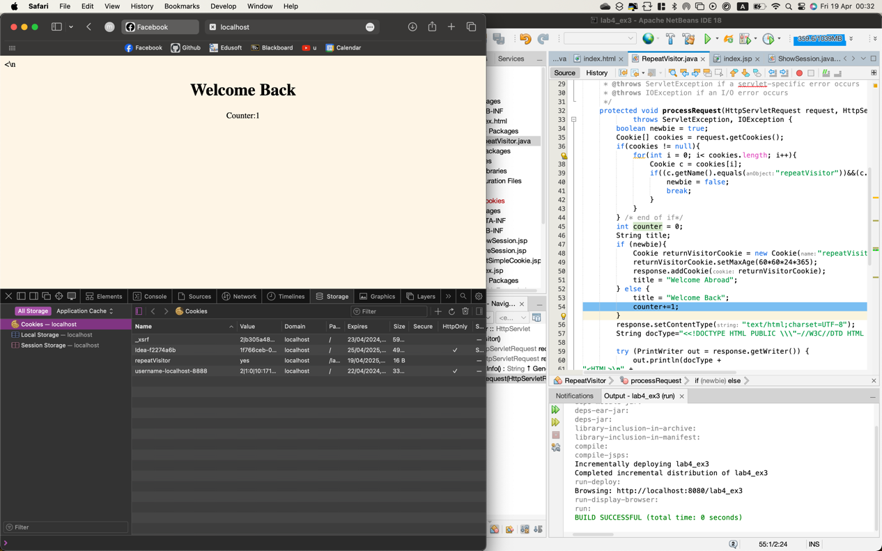

Exercise 4:

ShowSession.java – servlet java class.

My code:

/*

* Click nbfs://nbhost/SystemFileSystem/Templates/Licenses/license-default.txt to change this license

* Click nbfs://nbhost/SystemFileSystem/Templates/JSP_Servlet/Servlet.java to edit this template

*/

import jakarta.servlet.ServletException;

import jakarta.servlet.annotation.WebServlet;

import jakarta.servlet.http.HttpServlet;

import jakarta.servlet.http.HttpServletRequest;

import jakarta.servlet.http.HttpServletResponse;

import jakarta.servlet.http.HttpSession;

import java.io.IOException;

import java.io.PrintWriter;

/**

*

* @author thanhphatchau

*/

@WebServlet(urlPatterns = {"/ShowSession"})

public class ShowSession extends HttpServlet {

/**

* Processes requests for both HTTP <code>GET</code> and <code>POST</code>

* methods.

*

* @param request servlet request

* @param response servlet response

* @throws ServletException if a servlet-specific error occurs

* @throws IOException if an I/O error occurs

*/

protected void processRequest(HttpServletRequest request, HttpServletResponse response)

throws ServletException, IOException {

response.setContentType("text/html;charset=UTF-8");

HttpSession session = request.getSession();

String heading;

Integer accessCount = (Integer)session.getAttribute("accessCount");

if (accessCount == null){

accessCount = new Integer(0);

heading = "Welcome, Newcomer";

} else {

heading = "Welcome back";

accessCount = new Integer(accessCount.intValue()+1);

}

session.setAttribute("accessCount",accessCount);

String title ="Session Tracking Example";

String doctype= "<!DOCTYPE HTML PUBLIC \\\"-//W3C//DTD HTML 4.0" + "Transitional//EN\\\">";

try (PrintWriter out = response.getWriter()) {

/* TODO output your page here. You may use following sample code. */

out.println(doctype+

"<html>"+

"<HEAD><TITLE>" + title + "</TITLE></HEAD>\n" +

"<BODY BGCOLOR=\"#FDF5E6\">\n" +

"<CENTER>\n" +

"<H1>" + heading + "</H1>\n" +

"<H2>Information on Your Session:</H2>\n" +

"<TABLE BORDER=1>\n" +

"<TR BGCOLOR=\"#FFAD00\">\n" +

" <TH>Info Type<TH>Value\n" +

"<TR>\n" +

" <TD>ID\n" +

" <TD>" + session.getId() + "\n" +

"<TR>\n" +

" <TD>Creation Time\n" +

" <TD>" +

session.getCreationTime() + "\n" +

"<TR>\n" +

" <TD>Time of Last Access\n" +

" <TD>" +

session.getLastAccessedTime() + "\n" +

"<TR>\n" +

" <TD>Number of Previous Accesses\n" +

" <TD>" + accessCount + "\n" +

"</TABLE>\n" +

"</CENTER></BODY></HTML>"

);

}

}

// <editor-fold defaultstate="collapsed" desc="HttpServlet methods. Click on the + sign on the left to edit the code.">

/**

* Handles the HTTP <code>GET</code> method.

*

* @param request servlet request

* @param response servlet response

* @throws ServletException if a servlet-specific error occurs

* @throws IOException if an I/O error occurs

*/

@Override

protected void doGet(HttpServletRequest request, HttpServletResponse response)

throws ServletException, IOException {

processRequest(request, response);

}

/**

* Handles the HTTP <code>POST</code> method.

*

* @param request servlet request

* @param response servlet response

* @throws ServletException if a servlet-specific error occurs

* @throws IOException if an I/O error occurs

*/

@Override

protected void doPost(HttpServletRequest request, HttpServletResponse response)

throws ServletException, IOException {

processRequest(request, response);

}

/**

* Returns a short description of the servlet.

*

* @return a String containing servlet description

*/

@Override

public String getServletInfo() {

return "Short description";

}// </editor-fold>

}

Output:

* When I run the project, index.jsp will be shown up to help me execute servlet class.
* When I first time visit the page, heading change to Newcomer and it also provides the time I visited the page and counts number of my access. Here, when I am a newcomer, number of previous accesses is 0.A screenshot of a computer

  Description automatically generated
* When I refresh the page, number of previous accesses is added up to 1.A screenshot of a computer

  Description automatically generated
* When I refresh many times, it will counts all my activities. For example, I refreshed the page 10 times, therefore, the number of previous accesses is 10.A screenshot of a computer

  Description automatically generated

**Assignment 2:**

Output:

* When I run the project, index.jsp shows a page includes username and password. I filled out the form to complete submission.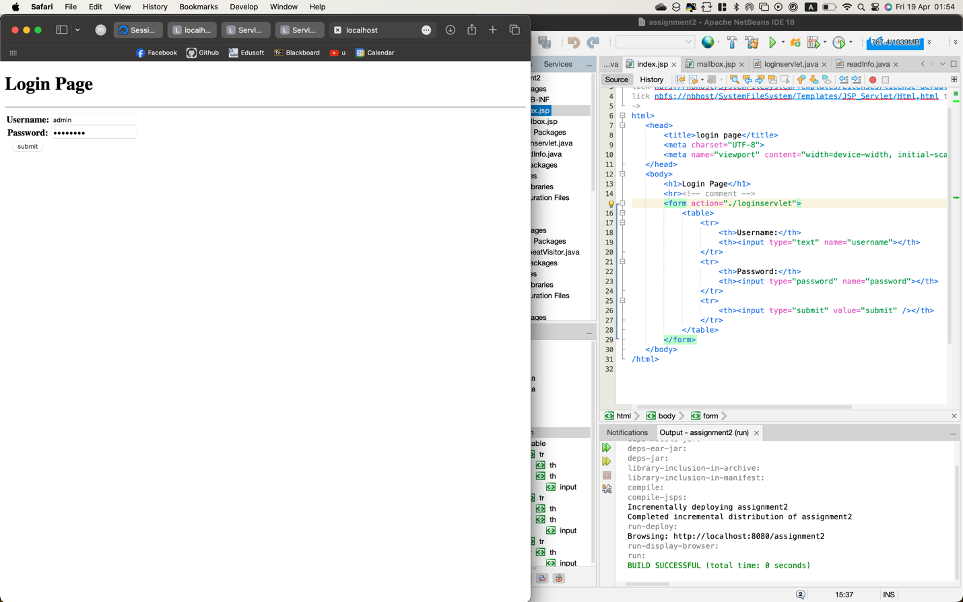
* When I input correct username and password, servlet move me to mailbox.jsp to fill out the form. A screenshot of a computer

  Description automatically generated
* Additionally, when I log in with correct username and password, a session is created.A screenshot of a computer

  Description automatically generated
* Finally, all the result will be printed out when clicking on Submit button.A screenshot of a computer

  Description automatically generated

My code:

Index.jsp:

<!DOCTYPE html>

<!--

Click nbfs://nbhost/SystemFileSystem/Templates/Licenses/license-default.txt to change this license

Click nbfs://nbhost/SystemFileSystem/Templates/JSP_Servlet/Html.html to edit this template

-->

<html>

<head>

<title>login page</title>

<meta charset="UTF-8">

<meta name="viewport" content="width=device-width, initial-scale=1.0">

</head>

<body>

<h1>Login Page</h1>

<hr><!-- comment -->

<form action="./loginservlet">

<table>

<tr>

<th>Username:</th>

<th><input type="text" name="username"></th>

</tr>

<tr>

<th>Password:</th>

<th><input type="password" name="password"></th>

</tr>

<tr>

<th><input type="submit" value="submit" /></th>

</tr>

</table>

</form>

</body>

</html>

Mailbox.jsp:

<%--

Document : mailbox

Created on : Apr 19, 2024, 12:49:19 AM

Author : thanhphatchau

--%>

<%@page contentType="text/html" pageEncoding="UTF-8"%>

<!DOCTYPE html>

<html>

<head>

<meta http-equiv="Content-Type" content="text/html; charset=UTF-8">

<title>JSP Page</title>

</head>

<body>

<h1>Register Mail Account</h1>

<hr><!-- comment -->

<form action="./readInfo">

<table>

<tr>

<td>Your Name:</td>

<td><input type="text" name="fname" placeholder="First name"><input name="lname" placeholder="Last name"></td>

</tr>

<tr>

<td>Gender:</td>

<td><input type="radio" name="gender" value="male">Male<input type="radio" name="gender" value="female">Female</td>

</tr>

<tr>

<td>Birthday:</td>

<td><input type="date" name="dob"></td>

</tr>

<tr>

<td>Major:</td>

<td>

<select name="major" size="1">

<option value="Computer Science">Computer Science</option>

<option value="Data Science">Data Science</option>

<option value="Network Engineering">Network Engineering</option>

</select>

</td>

</tr>

<tr>

<td>I live in:</td>

<td><input type="text" name="address"></td>

</tr>

<tr>

<td>Select ID:</td>

<td><input type="email" name="mail" placeholder="your_id@gmail.com"></td>

</tr>

<tr>

<td><input type="submit"></td>

<td><input type="reset" value="cancel"></td>

</tr>

</table>

</form>

</body>

</html>

Loginservlet.java:

/*

* Click nbfs://nbhost/SystemFileSystem/Templates/Licenses/license-default.txt to change this license

* Click nbfs://nbhost/SystemFileSystem/Templates/JSP_Servlet/Servlet.java to edit this template

*/

import jakarta.servlet.RequestDispatcher;

import jakarta.servlet.ServletException;

import jakarta.servlet.annotation.WebServlet;

import jakarta.servlet.http.Cookie;

import jakarta.servlet.http.HttpServlet;

import jakarta.servlet.http.HttpServletRequest;

import jakarta.servlet.http.HttpServletResponse;

import jakarta.servlet.http.HttpSession;

import java.io.IOException;

import java.io.PrintWriter;

import static org.glassfish.soteria.Utils.encodeURL;

/**

*

* @author thanhphatchau

*/

@WebServlet(urlPatterns = {"/loginservlet"})

public class loginservlet extends HttpServlet {

private static final long serialVersionUID =1L;

private final String userID ="admin";

private final String password ="password";

/**

* Processes requests for both HTTP <code>GET</code> and <code>POST</code>

* methods.

*

* @param request servlet request

* @param response servlet response

* @throws ServletException if a servlet-specific error occurs

* @throws IOException if an I/O error occurs

*/

protected void processRequest(HttpServletRequest request, HttpServletResponse response)

throws ServletException, IOException {

String user = request.getParameter("username");

String pass = request.getParameter("password");

if(userID.equals(user)&&password.equals(pass)){

HttpSession session = request.getSession();

session.setAttribute("user","thanhphatchau");

session.setMaxInactiveInterval(30*60);

Cookie userName = new Cookie(pass, user);

response.addCookie(userName);

String encodedURL = response.encodeRedirectURL("mailbox.jsp");

response.sendRedirect(encodedURL);

} else{

RequestDispatcher rd = getServletContext().getRequestDispatcher("/index.jsp");

PrintWriter out = response.getWriter();

out.println("<font color=red>Either username or password is wrong.</font>");

rd.include(request,response);

}

}

// <editor-fold defaultstate="collapsed" desc="HttpServlet methods. Click on the + sign on the left to edit the code.">

/**

* Handles the HTTP <code>GET</code> method.

*

* @param request servlet request

* @param response servlet response

* @throws ServletException if a servlet-specific error occurs

* @throws IOException if an I/O error occurs

*/

@Override

protected void doGet(HttpServletRequest request, HttpServletResponse response)

throws ServletException, IOException {

processRequest(request, response);

}

/**

* Handles the HTTP <code>POST</code> method.

*

* @param request servlet request

* @param response servlet response

* @throws ServletException if a servlet-specific error occurs

* @throws IOException if an I/O error occurs

*/

@Override

protected void doPost(HttpServletRequest request, HttpServletResponse response)

throws ServletException, IOException {

processRequest(request, response);

}

/**

* Returns a short description of the servlet.

*

* @return a String containing servlet description

*/

@Override

public String getServletInfo() {

return "Short description";

}// </editor-fold>

}

*readInfo.java:*

/*

* Click nbfs://nbhost/SystemFileSystem/Templates/Licenses/license-default.txt to change this license

* Click nbfs://nbhost/SystemFileSystem/Templates/JSP_Servlet/Servlet.java to edit this template

*/

import jakarta.servlet.ServletException;

import jakarta.servlet.annotation.WebServlet;

import jakarta.servlet.http.Cookie;

import jakarta.servlet.http.HttpServlet;

import jakarta.servlet.http.HttpServletRequest;

import jakarta.servlet.http.HttpServletResponse;

import java.io.IOException;

import java.io.PrintWriter;

/**

*

* @author thanhphatchau

*/

@WebServlet(urlPatterns = {"/readInfo"})

public class readInfo extends HttpServlet {

String username;

String password;

/**

* Processes requests for both HTTP <code>GET</code> and <code>POST</code>

* methods.

*

* @param request servlet request

* @param response servlet response

* @throws ServletException if a servlet-specific error occurs

* @throws IOException if an I/O error occurs

*/

protected void processRequest(HttpServletRequest request, HttpServletResponse response)

throws ServletException, IOException {

response.setContentType("text/html;charset=UTF-8");

Cookie[] cookies = request.getCookies();

for(int i =0; i < cookies.length; i++){

Cookie c = cookies[i];

String name = c.getName();

String value = c.getValue();

if(name.equals("password")&&value.equals("admin")){

username = value;

password = name;

}

}

String name = request.getParameter("fname") + request.getParameter("lname");

String gender = request.getParameter("gender");

String dob = request.getParameter("dob");

String major = request.getParameter("major");

String living = request.getParameter("address");

String email = request.getParameter("mail");

try (PrintWriter out = response.getWriter()) {

/* TODO output your page here. You may use following sample code. */

out.println("<!DOCTYPE html>");

out.println("<html>");

out.println("<head>");

out.println("<title>Servlet readInfo</title>");

out.println("</head>");

out.println("<body>");

out.println("<h1>Reading Personal Information</h1>");

out.println("<table border=1 align=\"center\"><tr><td>Your name:</td><td>"

+name+"</td></tr>"+

"<tr><td>Gender:</td><td>" + gender +"</td></tr>"+

"<tr><td>Birthday:</td><td>" + dob +"</td></tr>"+

"<tr><td>Major:</td><td>" + major +"</td></tr>"+

"<tr><td>I live in:</td><td>" + living +"</td></tr>"+

"<tr><td>Email adress:</td><td>" + email +"</td></tr>" +

"<tr><td>Username:</td><td>" + username +"</td></tr>" +

"<tr><td>Password:</td><td>" + password +"</td></tr>"

);

out.println("</body>");

out.println("</html>");

}

}

// <editor-fold defaultstate="collapsed" desc="HttpServlet methods. Click on the + sign on the left to edit the code.">

/**

* Handles the HTTP <code>GET</code> method.

*

* @param request servlet request

* @param response servlet response

* @throws ServletException if a servlet-specific error occurs

* @throws IOException if an I/O error occurs

*/

@Override

protected void doGet(HttpServletRequest request, HttpServletResponse response)

throws ServletException, IOException {

processRequest(request, response);

}

/**

* Handles the HTTP <code>POST</code> method.

*

* @param request servlet request

* @param response servlet response

* @throws ServletException if a servlet-specific error occurs

* @throws IOException if an I/O error occurs

*/

@Override

protected void doPost(HttpServletRequest request, HttpServletResponse response)

throws ServletException, IOException {

processRequest(request, response);

}

/**

* Returns a short description of the servlet.

*

* @return a String containing servlet description

*/

@Override

public String getServletInfo() {

return "Short description";

}// </editor-fold>

}